Ants
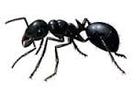
Black Ant
Black Ants are one of the most successful groups of insects. They are social insects that live in colonies, which are usually located in the ground, but may enter buildings for shelter and/or food.
Black Ants feed on practically any food, but those entering homes are looking for sweets and/or protein containing substances such as sugar.
Black Ants are usually divided into two groups based on their typical nesting preferences, either wall nesting, or ground nesting ants. The biology and habits of each species are different. The most common wall nesting ant is the Pharaoh’s Ant (search Pharaoh's Ant) and the most commonly nesting ground ants are the Common Black Ants as depicted above.
The life of the Black Ant is mainly spent outside in the soil and under paving slabs, but because of the foraging for food they enter indoors and become a problem. As they forage for food they leave scent trails for the other Ants to follow, which is why you often see long lines of Ants. They are a very social insect and that is the reason that you see them in large numbers.
Not really considered a nuisance pest, but if they are running all over your worktops in the Kitchen you may feel differently, so if you think you need help please contact a Registered Member from within the Site for further advice.
Losses of goods, quality, loss of goodwill, prevention of damage, prevention of contamination are good reasons to control Black Ants.

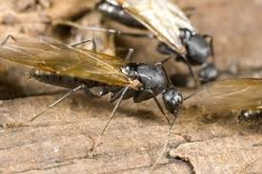
Flying Ants
Generally speaking you will only see Flying Ants in and around your garden and home during their one nuptial flight on a hot summer’s day. During the flight virgin Queen Ants will mate with males and then land to start a new colony, it's as simple as that.
However, if you are confronted by this spectacle it's not so funny at the time, even though it's unlikely to cause you any harm. Smaller numbers can be easily dealt with using Aerosol sprays, but maybe the time to call in a Professional Pest Control Company Registered Member is if a colony of Flying Ants comes up from beneath your floorboard’s, or skirting board areas for example. That itself may indicate that you have one, or perhaps several Ant colonies under the floorboards of your home, and therefore they may need to be eradicated professionally.

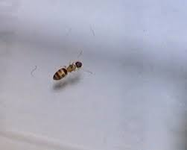
Ghost Ants
The Ghost Ant is sometimes also referred to as the Black Headed Ant. This particular Ant is small at 1.5 mm in length, with a dark head (hence the name) and thorax. The pale coloured, almost translucent abdomen and legs, in addition to its minimal size gives the Ghost Ant its name.
Although it only arrived in the UK recently and is still relatively rare, the Ghost Ant is spreading quickly, particularly in Housing developments, Care Homes, Hospitals and is not unlike the Pharaoh Ant.
A Ghost Ant colony may well contain many thousands of workers and multiple Queens. They have a preference for sweet foods such as sugar, honey, syrup, jam but outdoors will feed on Aphids extracting the fluids from their body.
In the event you have an infestation of Ghost Ants you will need a Professional Pest Control Company Registered Member to resolve matters.
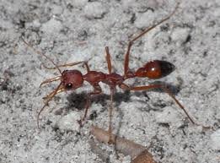
Red Ants
Trust me Red Ants do sting! These aggressive little Red Ants will spoil any picnic but are easily controlled. Contact our Professional Registered Members for advice.
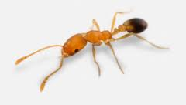
Pharaoh Ants
The Pharaoh Ant is a nasty little Ant that's for sure. Found generally in Hospitals, Nursing Homes, Care Homes, Restaurants and School Kitchens. Professional advice from a Registered Member will be required to deal with this infestation.
During many years as a pest control officer I was called to infestations of 'Ants' in hospitals that would often be described as "little see through things crawling over the worktop and around our tea making area". On arrival it was clear that the hospital was infested with Pharaoh's Ants which used to be notoriously difficult to deal with, baiting often took place over a period of six months or more.
On closer inspection the Pharaoh's Ants were found to be throughout several floors of the hospital, but it didn't stop there. They were in the ducting on the ground floor, in the drains and outlets where blood, faeces and sputum was present. The Pharaoh's Ants were very happy in that environment because they survive on a high protein diet. But the most shocking discovery was the presence of the Pharaoh's Ants in the hospital wards where they were actually found crawling up the metal frame of the beds, and into bed with the patient potentially feeding and infecting, or further infecting wounds both before and after surgical procedures had been carried out.
Colonies of Pharaoh's Ants tend to be large, with workers numbering in the thousands, tens of thousands, to several hundred thousand. New Pharaoh's Ants nests can be formed by "budding" with as few as five workers, with ten pre-adults and one Queen migrating from the original colony. Development time from egg to adult for workers is about thirty eight days at 27°c. Workers live for about nine to ten weeks, and the males die about three to five weeks after mating. More than a dozen pathogenic bacteria have been found on Pharaoh’s Ants collected in hospitals.
Inside Pharaoh Ants nest in warm (30°c) and humid areas near sources of food and water. Nests are usually located in inaccessible places such as wall voids, under floorboards, in furniture etc. They commonly use electrical and telephone wires as a route to travel through walls and between floors. Pharaoh's Ants are common problems in commercial food handling places such as hotels, grocery stores, hospitals and in apartment complexes.

